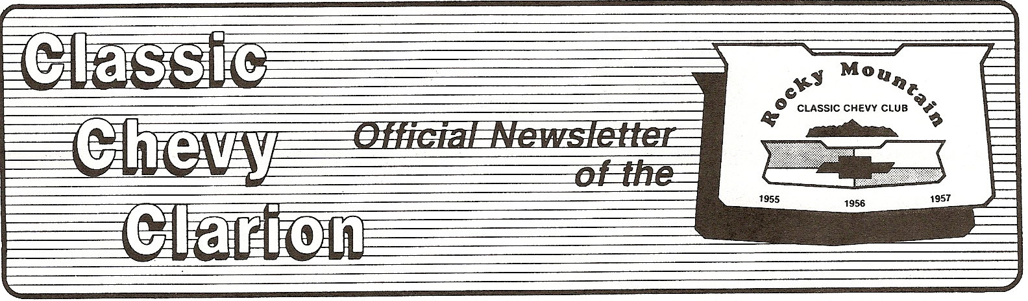

**NEXT SCHEDULED MEETINGS**

**SATURDAY, FEBRUARY 12, 2011**

**SATURDAY, MARCH 12, 2011**

**7:00 P.M. – GAVEL FALLS**

**LOCATION: ANNE CAMPBELL ROOM**

**ARVADA POLICE STATION**

**ARVADA, COLORADO**

**THIS NEWSLETTER IS DEDICATED TO THE MEMORY OF**

**MEL DYSON**

**CLUB SECRETARY**

**FOR OVER TEN YEARS**

|  |  |  |  |  |
| --- | --- | --- | --- | --- |
|  |  |  |  |  |

[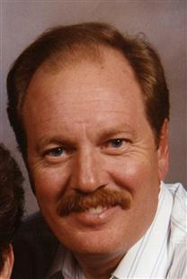](http://obits.dignitymemorial.com/dignity-memorial/modals/image-gallery.aspx?n=Mellis-Dyson&lc=4958&pid=145831047&mid=4401603)

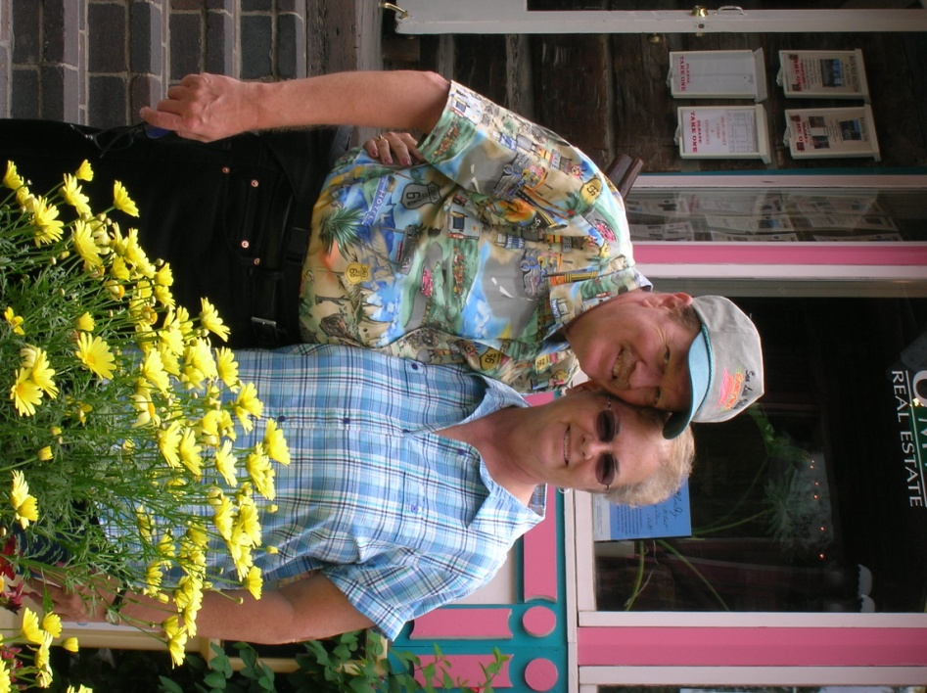

**Janice and Frank Adams**

Mel was a kind and gentle soul.  Unfortunately, I did not know Mel as long and many of the other club members.  When I lost my daughter, he was there for me.  On a lighter side, Mel was my carburetor man.  He came over one weekend and we rebuilt the carb on the comet.  It was only a single throat, but carbs scared me. In no time at all, we tore it down soaked out the gunk and put it back together.  Mel wanted to fine tune it, but I didn't think it was necessary.  It is still running today the way he set it.

Cruising with Mel was always fun.  I never had to worry about running out of gas as long as he was driving Poison Ivy.  The gas stops were frequent!

Janice and I will Miss him.  Our love and prayers go out to Mel, Donna and Wendy and family!

**Fred and Jo Barnes**

Mel Dyson was a rare person that would do anything or give you anything whether it be friend or foe. He liked people and was so easy to have as a friend. We have so many precious memories he could also give that Chevy a royal cussin’ when it failed him. We would laugh at him and that didn’t help matters at this the time. Miss him – yes. But we are blessed to have called him “friend”.

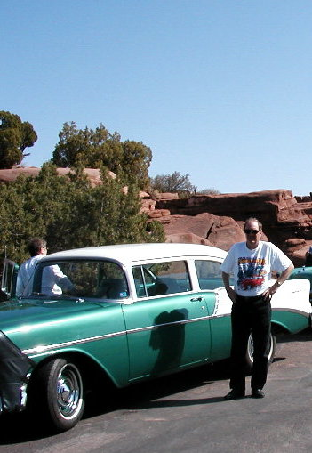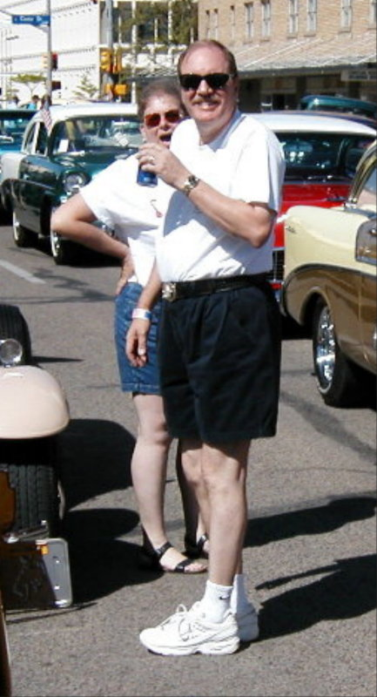

**Pam and Don Spaulding**

Mel was always teasing me about something which made me laugh.  I looked forward to his jokes and jabs.

Mel was also so positive about life. If you felt you were in a jam he would step you through the problem until you found your way out. He had an abundance of patience in this area.

I do remember a few conversations about Boy Scouts.  Don and I were working with the cubbies at our church.  There were always situations that came up with inner city kids that were so different from the way we were brought up.  The conduct and language of some the boys were so unacceptable to us.  What a test they put us through, especially Don.  It was quite shocking with some of the young boys actions.   I mentioned some of these issues to Mel one evening.  He had some similar experience being in Boy Scouts most of his life so I listened carefully to his thoughts, ideas, suggestions, etc.  After a good long discussion I walked away with a different outlook and mind set.  He had no idea what a tremendous impact he left on me with what Boy Scouts was intended for and how I could use that to help reach these boys.  I saw the issues on a different level and because of that I could have a positive impact and response from them.  I am so grateful we had that talk day because it did make a difference.  Thanks Mel!

We had many discussions on cars, of course.  I remember one in particular after I got new Wheels on my 56.  When Mel first saw my new wheels, he told me he loved them and if I ever wanted to sell them, he would buy them from me.  It made me feel good that Mel would want them on his 56 too.

I am blessed that Mel was a part of my life and he will always have a special place in my heart.

Blessings and lots of love to Donna and family.

**Bev DeBoer**

I remember Mel as being a very caring and dedicated person.  He always was so faithful as RMCCC Secretary and as a member of the Old Car Council.  When we became new members in the car club, Mel and Donna were very friendly to us and we enjoyed several out of town trips with them and the car club.  I remember the trip when a car rolled down the hill and crashed into his 1956 Chevy.  He handled this better than most of us would have.  I enjoyed seeing him relate well with his family and grandchildren.  It is not the same attending the meetings now without him being there.  Really will miss him.

**Janet and Gary Diddy**

We remember our car show trips to various sites, the stopping for gas every 100 miles or so and the pleasure that Mel got from listening to his glass packs especially going down hill and shifting from 4th to 3rd and enjoying that backfiring.  

**Dan Jetter**

I met Mel and his wife, Donna, many years ago through the mutual friends of Greg and Kay Horn. They were in the “CLASSIC CHEVY CLUB” and my brother, Roger, and I had a couple of ’57 Chevys. One was painted gray and had some body modifications, which Roger drove all the time. The other ’57 is painted mint green, radical body work and we still own it. We would cruise both ‘57’s and got to know Mel with his ’56 at some of the different cruises around the metro area, or at the Horn’s house for an afternoon BBQ.

Mel and Donna would come by Rosie’s Diner on Wednesday evenings during the summer for the cruise night, either driving the ’56 or the newly acquired ’62 black Impala. Both of those vehicles were immaculate and he took very good care of each one. He enjoyed cruising either one of them and showing them off to us other car guys.

Mel will be missed, but in spirit he will be cruising with all of us.

**Bob and Doña** **Olivier**

In fond remembrance of our good friend Mel,

 What can be said about a wonderful man except much praise. His friendship is greatly missed by Bob and I. Many of our excursions revolved around classic cars of course, but there were also many get-togethers that were because we just enjoyed each others company. Laughing together was wonderful – his sense of humor brought many giggles from us gals.

I recall one trip to the Casper Car Show when we pulled into a gas station on the journey there. Mel and Donna behind us at the pump. Mel noticed that his license plate was expired by 1.5 years! Nothing to do but have Mel stay close behind our car all the way so the police would not notice. Bob took care of that issue really quickly. I think the new ones were in a pile at home - forgotten.

I’m sure we will all miss the walkie-talkies he supplied for keeping the long stream of cars together on cruises. He was very dedicated to serving for the Rocky Mountain Classic Chevy Club as secretary for many, many terms and was the representative at the Old Car Counsel. I felt so bad that when he asked for relief from secretary position no one stepped forward, until we all hurt for him. Mel always willingly helped with the parking set up for car shows and pitched in with any task that needed doing.

One year their classic car was under the weather after it was rolled into, but they went to the Goodland Kansas show anyway with their daily driver just to be in on all the fun. They hopped in with us to drive around town and to the car show. At an antique shop’s yard sale, I found a metal table and four chairs that I had to have. It would not fit in our 56 Chevy so they filled their car with it and hauled it home for us. I think of that trip every time we have breakfast outside while looking at the Front Range.

For several seasons Donna and I kept an eye out for a turquoise watchband for Mel. So many found he did not like. We were happy to see he finally found one in Taos and we liked seeing him wear it.

 We admired his honoring of young men in the armed services, when he would go up to them and thank them for their service. He knew what armed service meant because of this time during the Vietnam War. Mel was very dedicated to his family – Donna, parents, his children, and grandchildren. He definitely fostered a love of cars with his grandchildren by bringing them to some club events. Mel wasn’t showy - he was honest and true.

|  |  |  |  |  |  |  |
| --- | --- | --- | --- | --- | --- | --- |
|  |  | | | | |  |
|  |  |  |  |  |  |  |

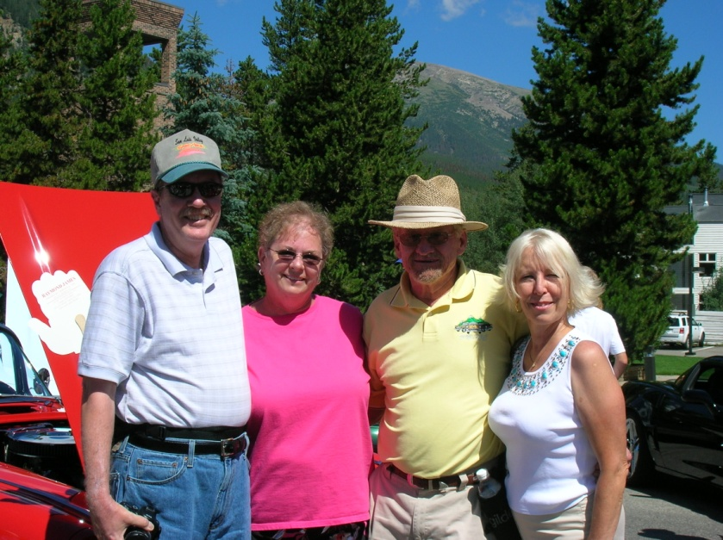

**Kathy and Gerry Eager**

I have many fond memories of time spent with Mel but just a couple of special moments I would like to share with you.

On one occasion at one of the car shows we attended in Casper, WY Mel and I decided we wanted some chicken gizzards to please our palettes. We grabbed Donna and Kathy and headed for downtown Casper in pursuit of our elusive quarry. We stumbled upon a unique establishment known as Sanford’s Grub & Pub. Its walls and rafters were littered with memorabilia and paraphernalia from the past. We spent a delightful afternoon recalling our past experiences with many of the antique items on display and had several discussions as to the use of some of the odder things that we could only describe as UFOs (Unidentifiable Fine-looking Objects) Oh yeah, we also enjoyed several libations and tried many different appetizers, including our chicken gizzards. As I said before, quite the delightful afternoon.

On a different trip to a car show in Deadwood, SD with Dave & Lorrie, Fred & Jo, Mel & Donna, Al & Deanna, myself & Kathy we pulled into Chugwater, WY because Mel thought he might need to refuel. We all welcomed the much needed pit-stop as an opportunity to “stretch our legs”, replenish our drink of choice and just prattle of the trip so far. We were several miles north of Chugwater when one of us alerted Mel that his fuel door was open on his ’56. Mel apologized for the delay but he needed to return to collect his forgotten gas cap. Mel flipped a u-turn on I-25 as we slowed our pace to allow him to catch up. We were all surprised when after only a couple of minutes Mel rejoined our little caravan. He sheepishly told us that he had replaced the cap and merely forgotten to close the door. Two illegal u-turns on an interstate within two minutes! Seems Mel forgot his own adage, “Keep it between the ditches, and Smokey off yer britches”.

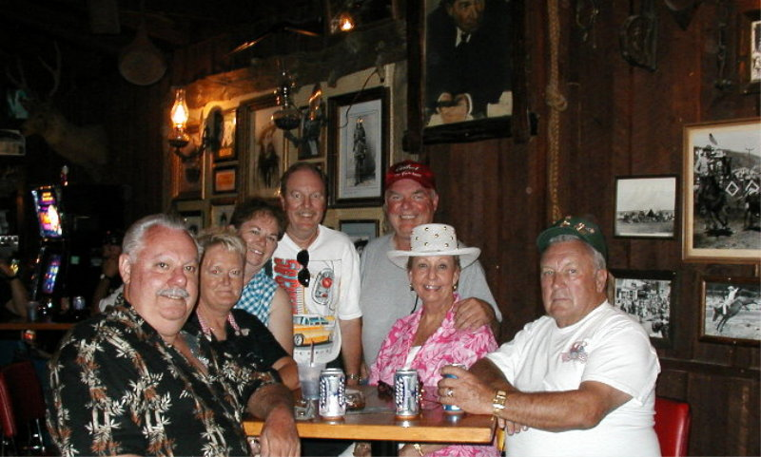

**Kay and Greg Horn**

A Sunday evening planned event for the Chevy Club ended up at Bennigans in Arvada

for dinner. Greg and Donna were seated next to each other and this so happened to be the area where the waitress lost control of her beverage tray thus showering both of them with beer. This included all that they were wearing and Donna’s leather jacket. The evening continued with laughter and teasing which they both handled quite well. On our way back to Aurora, we felt Mel pulling up beside us to wave good-bye before we reached the 225 exchange. However, this time Mel was in the center lane and peddling hard so we could see Donna with her leg out the window in what, she claimed, was an effort to dry her pants.

The corner of Chambers and Colfax was always our meeting place for car trips across town. Often the green/white would be parked waiting for us. If we arrived first, we sat and listened for Mel’s distinct sounding exhaust system to announce they were near even before they pulled into the parking lot. That corner will never be the same but has a special memory etched in our minds.

We were very fortunate to have shared a trip with Mel, Donna, and Flat Stanley to the

Reno/Lake Tahoe area in March. Even though Mel was dealing with his cough, we all enjoyed our late night arrival, an unexpected upgrade to the Concierge level of the Atlantis, and taking advantage of our every opportunity to eat.

Mel was the parking expert for our All Chevy Day Car Shows and for the two Western

National Conventions which the club hosted. Of course, he always helped in other categories as well, but the parking was his expertise and pretty much his baby.



**Ray and Diane Briscoe**

Our greatest memory of Mel is from the car show we attended with he and Donna in North Platte, NE in September, 2009.  We met at their house and caravaned with them and their Ford friends, Chuck and Ginger Freeman. Mel "showed us the ropes" as this was one of our earliest car shows out of state.  It was a great weekend and we feel fortunate to have attended that show with them.   He was very welcoming and friendly and had a great knowledge of Tri-5's.  We have great memories from that weekend; good food, dancing and many, many classics.  Also, he was an organized Secretary for RMCCC with an eye for detail.  He and Donna put a lot of work into helping the club and he was an outstanding member.  He will be missed. We are thankful to have known him, the time was just too short.

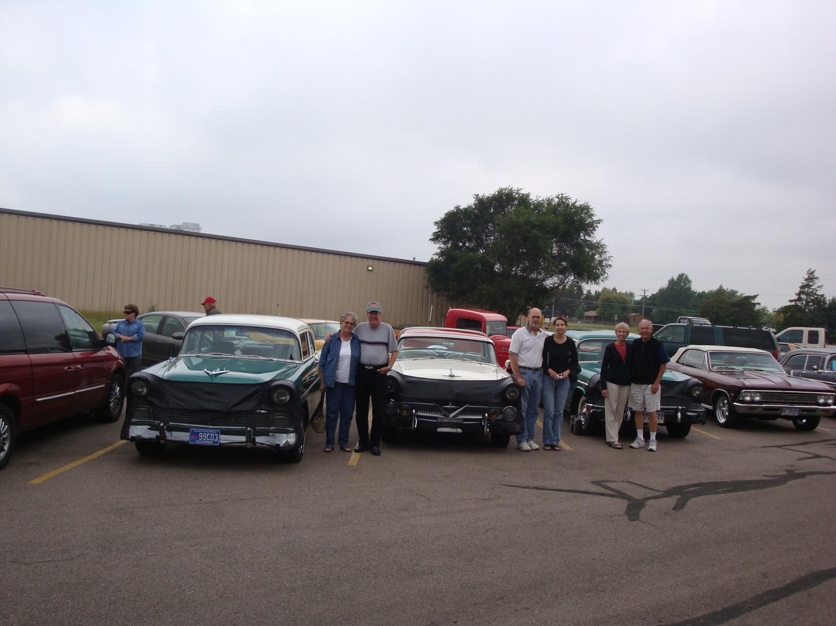

"Colonel Cody's Cruise" in North Platte

**Wendy and Jerry Haselgren**

It was a pleasant July night at Colorado National Speedway a few years back but one we won't soon forget;

Things went something like this. It wasn't too far into the racing program that the snacks started to appear. Jerry and I had packed a small soft sided cooler with what later turned out to be an inadequate amount of food and beverages. We figured that what we packed would satisfy our needs for the evening. Well now, between the Dysons and the Oliviers we quickly realized that were greatly under provisioned. We saw copious amounts of sandwiches, grapes, trailmix, cookies,various cheese offerings, drinks, candybars and other various and sundry offerings. Each of the above mentioned couples graciously offered their surpluses to the woefully unprepared Haselgrens. I believe it was Mel who stated, "you should see what Donna packs for bigger and longer events." Well because of that evening and the things we learned, pack as if you will be stuck somewhere for three days.

God Bless you Dysons!

**Gene and Gale Hatley**

We remember the trip up to Pine with Mel & Donna, Greg & Kay, Myron & Bev, Bob & Dona’. It was a good trip. Gene believes that we did the Pine parade first and then went to an old store and gas station.

We had a lot of good times with Mel and Donna at parades, cruises and car shows. When we went on a cruise with Mel we always gauged our gas on Mel whether we needed it or not. He always had a smile and was always ready to help if someone needed it. We also remember the last Rosie’s Diner show he came to. We were surprised and pleased at the same time to see him there.

We miss him as we are sure all of you do too.

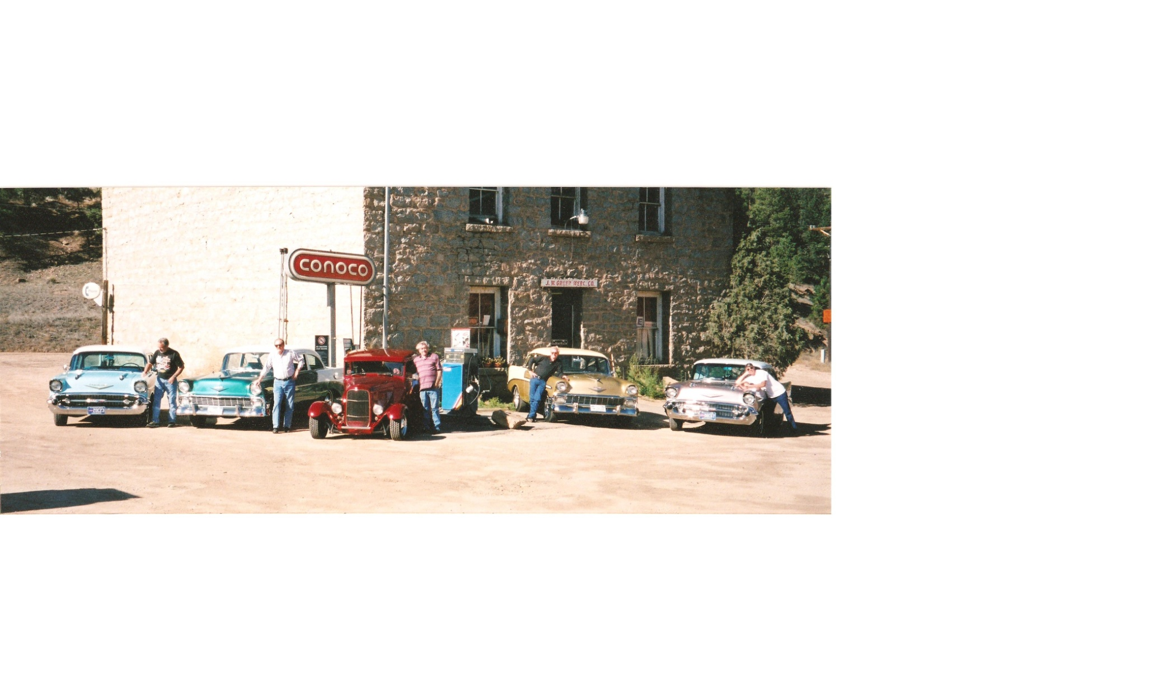

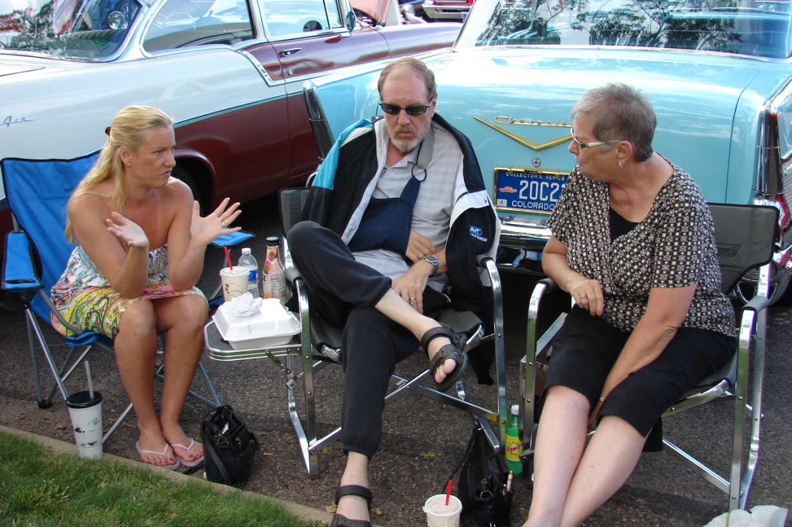

**John and Evelyn Warren**

Our first recollection of spending time with Mel and Donna was at a Commerce City parade. Everyone needed to be lined up hours before the parade started and the RMCCC club always seemed to be towards the end of the parade. Finally, every one started moving but half way thru the parade Mel’s car over heated. In a desperate attempt to stop the water from spewing out the radiator Mel stuck bubble gum from his grandkids onto the top. We all learned an important message from Mel that day a hot radiator and bubble gum doesn’t solve the problem but makes for one sticky mess.

Another outing we recall is our trip to Fruita. Three couples (the Dysons, Diddys and Warrens) left for Fruita for the Mike’s Headless Chicken car show. We made a stop at our favorite gas station in Silverthorne yes Mel needed gas to be sure he’d make it the rest of the way. Then onto Glenwood Springs for lunch at a drive in with great hamburgers and buffalo burgers. Mel had introduced everyone in the club to this stand, we’re sure it was his favorite place. We stopped for gas after lunch and Mel discovered he’d left his gas cap at the Silverthorne station. Not to worry on the return trip on Sunday afternoon stopped at the same station and yes to everyone’s surprise there was the gas cap.

Mel learned that evening at the motel when playing cards you need to watch Janet Diddy and her spilled coffee. The local television station 10 o’clock news made celebrities of our 3 cars at the car show.

Sunday morning brought problems Mel had a dead battery in his 56. After a jump start, off to breakfast. After breakfast and another jump start we headed for the Gateway Car Museum. After another jump start we left the museum and headed towards home. Mel didn’t make it any farther than Rifle when the battery went totally dead in his car. After putting a battery and alternator in the car everyone made it home. Come to find out Mel’s only problem was the battery, so Mel now had a spare alternator. Checker and their woman employee were wrong.

Mel is missed and we are honored to have known him.

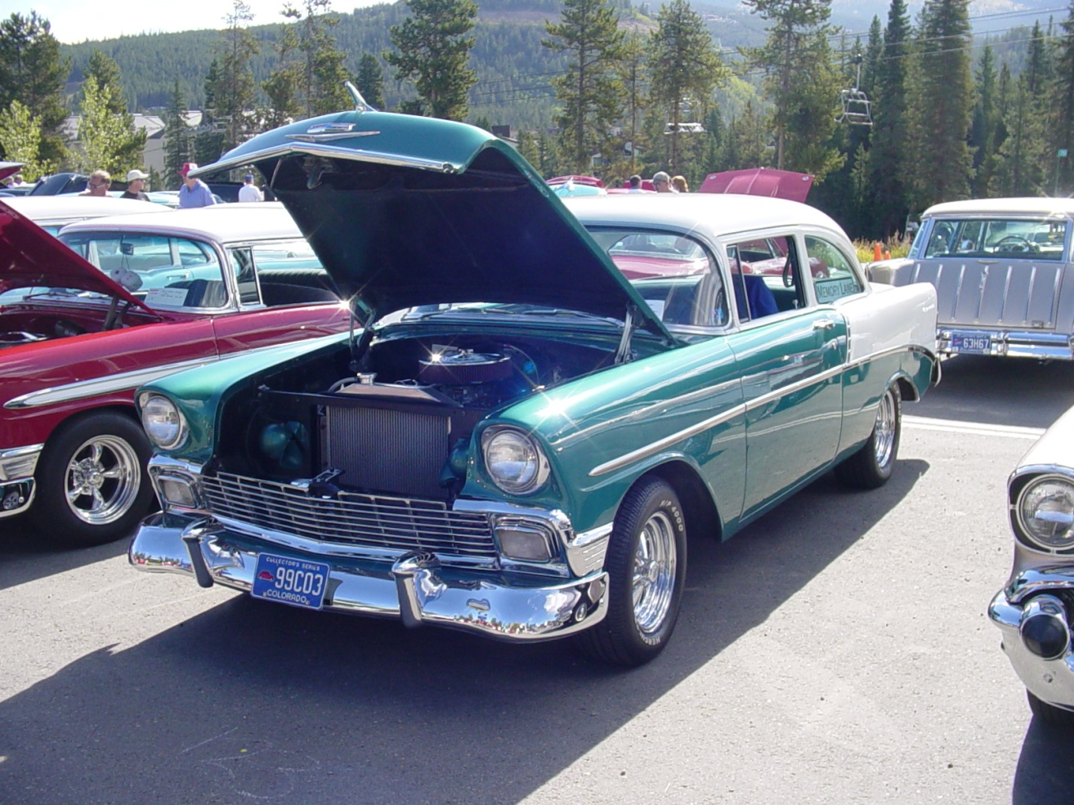

**Larry & Sharon Hart**

As I sit here thinking about the wonderful times we’ve had with the car club, with Mel and Donna, I am thankful for a decision we made one beautiful Saturday in June, 2003. We decided to go to All Chevy Day at Rosie’s in Aurora. There we met the member s of the Rocky Mountain Classic Chevy Club.

For the past seven years, we have great memories of car shows, both in town and out of town. Each show brings its own special memories.

We first met Mel and Donna at Rosie’s, then after joining the club, we were asked to serve on a committee along with the Dilbeck’s and the Dyson’s. We met several times for dinner to discuss our recommendations to the club. We all quickly became friends and realized that we had more in common than our cars. It was then that we realized that even though Mel had a beautiful car (with a cool wolf-whistle), that he was a very loving and compassionate man.

Last year we hosted an anniversary dinner for the Diddy’s. Mel and Donna attended. We sat around the table and talked (mostly laughed) about how each couple had met and about our early lives. Mel and Donna talked about the trip in the convertible where Donna threw her cigarette out of the car, only for it to land on the convertible top! How many new husbands would have been as forgiving as Mel? Not many.

Mel was very proud of his heritage (his dad was a Pearl Harbor survivor). Proud of his kids, Todd and Wendy, and his grandkids. And he loved Donna!!!!!

So even though we met because of a common interest in cars, Mel was so much more. We will miss him, but we will remember him always

